LIME Garcon   
***Serving you the numbers you care about***

## Info

The LIME Garcon brings you your personalized daily information needs served at your fingertips. This addictive app not only saves you time but also keeps you up-to-date with the information you desire.

## Installation

Copy "garcon" folder to the “apps” folder.

Add the following HTML to the index.html, see setup below for configuration settings:

Create table “Garcon” with the necessary fields, see installation document

## Description

The LIME Garcon presents the result from filters that you setup in LIME. A filter could for instance be “history notes made on my customers by anyone else but myself during last day” and present a “# new history notes” on your actionpad.

Each item can use individual color settings making it easy to identify urgency.

When you click on the text, LIME will bring you to the correct table with the appropriate filter.

As you set your filters yourself, only you, LIME and the sky is the limit.

## Settings

COWORKER Defaulted to active user

ALL Click the field if everyone should see this filter

LABEL The text that follow the filter result number, i.e. “result” + “new history notes”

ICON Icon with search help to identify accepted icon names

TABLE Table where your filter is located

FILTER Filter that will produce the result, i.e. number of hits matching your filter

COLOR Background color

VISIBLE… When ticked, item will be shown on the list when result is zero.

SORT Sort order on actionpad

## Suggested field setup

### Database names

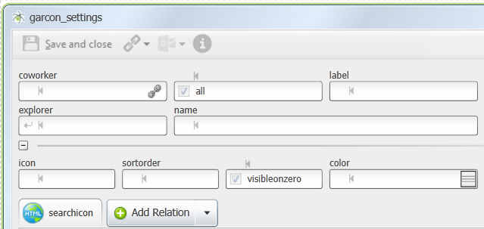

### Swedish names

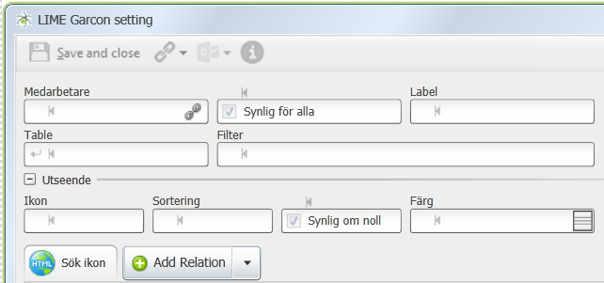

### English names

